**Ch22**

**5. Equation for the Synthesis of Aspartate from Glucose**

Net equation: 1/2Glucose + CO2 + NH3 → Asp + H+ + H2O

**9. Concerted Regulation in Amino Acid Biosynthesis**

If *E.coli* grow in a medium rich in histidine, histidine doesn’t play a central role to regulate the activity of glutamine synthesis. For enzyme is regulated by multiple downstream compound, though histidine has few effects to change the activity of enzyme, other compound can give a feedback to glutamine synthesis to make deal with the change of the other downstream compound. That makes organism batter adapt the surrounding.

**11. Nucleotide Biosynthesis in Amino Acid Auxotrophic Bacteria**

Considering the mutant unable to synthesis glycine, it cannot *de novo* synthesis purine for glycine is a crucial compound provide 2 carbon atom and 1 nitrous atom.

For glutamine synthesis mutant, it is incapacity to *de novo* synthesis both pyrimidines and purine. In pyrimidine synthesis, Gln is the amino donor to synthesis carbamoyl phosphate that take part in cytosine synthesis. Also, the Gln is the nitrous donor to purine. So, the Gln auxotroph cannot synthesis purine and cytosine.

For aspartate auxotroph, it cannot synthesis all kinds of bases. Asp is the nitrous donor, so the incapacity of Asp synthesis blocks the *de novo* synthesis of purine. In the other hand, Asp provide 4 atoms in pyrimidine atom bone. So, the synthesis of pyrimidine is unable to occur without Asp.

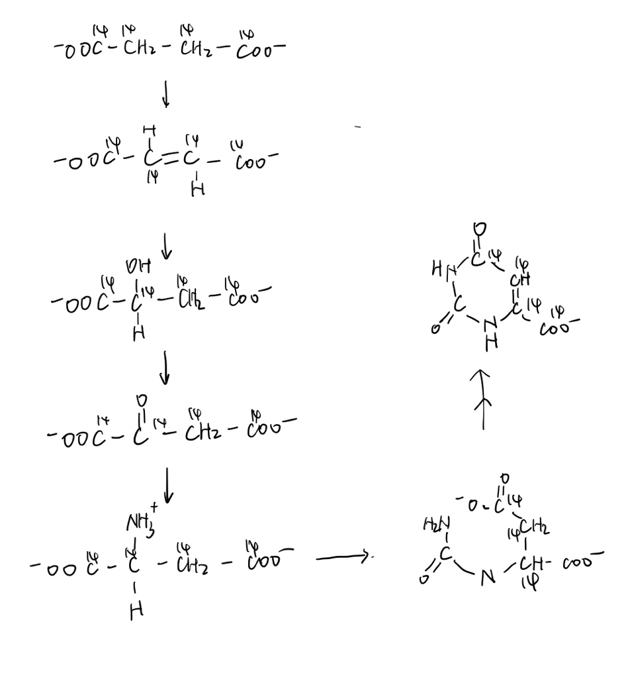**14. Pathway of Carbon in Pyrimidine Biosynthesis**

**15. Nucleotide as Poor Source of Energy**

In cells, nucleotide is considered to be the carrier of genetic information. It doesn’t accumulate in the cytosol as fuel. In the other hand, nucleotide is not a good source of energy. First, ring of nucleotide is highly oxidized during the process of synthesis, in this case, it’s hard for organism to oxidate them to release energy. Second, the ring of purine or pyrimidine has a really low C/N ratio. It is also unfavorable to be the fuel.

**16. Treatment of Gout**

The xanthine oxidase catalyzes two reactions, from hypoxanthine to xanthine and from xanthine to uric acid. In cell, adenosine is converted to hypoxanthine first and the inhibition of xanthine oxidase cause the accumulation of hypoxanthine, for hypoxanthine is more soluble than uric acid, it less likely to cause kidney diseases. Considering guanine degradation, guanine is converted to xanthine directly, so the inhibition to xanthine oxidase cause the accumulation of xanthine in cells, however, amount of guanine in cell is lower than adenine. So, though the solubility of xanthine is lower than uric acid, less guanine is produced than uric acid in untreated gout patient.

**Extra question**

What is the reaction catalyzed by ribonucleotide reductase? What are the substrates of this enzyme? How is this enzyme regulated?

The reaction catalyzed by ribonucleotide reductase is the conversion from ribose in nucleotide to deoxyribose. The substrate is NDP. Considering the regulation of enzyme, not only the activity of enzyme is regulated, but also the specify of which. ATP activate the enzyme whereas dATP inhibit it. Also, when dATP or ATP binds, reduction of CDP and UDP is favored; when dTTP binds, reduction of GDP is favored (and the reduction of CDP and UDP is inhibited); when dGTP binds, reduction of ADP is favored.